**广东海洋大学学生实验报告书（学生用表）**

**GDOU-B-11-112**

|  |  |  |  |  |  |  |  |  |  |  |  |  |  |
| --- | --- | --- | --- | --- | --- | --- | --- | --- | --- | --- | --- | --- | --- |
| 实验名称 | 仿腾讯新闻网的html页面 | | | | 课程名称 | | 用户界面设计 | | | | 课程号 | |  |
| 学院(系) | 数计（软件）学院 | | 专业 | 软件工程 | | | | | 班级 | | 软件1172 | | |
| 学生姓名 | 黄国铭 | 学号 | 201711701206 | | | 实验地点 | |  | | 实验日期 | |  | |

1. 实验目的

学习页面布局 并模仿腾讯新闻网首页编写html及css

1. 网页基本结构分析

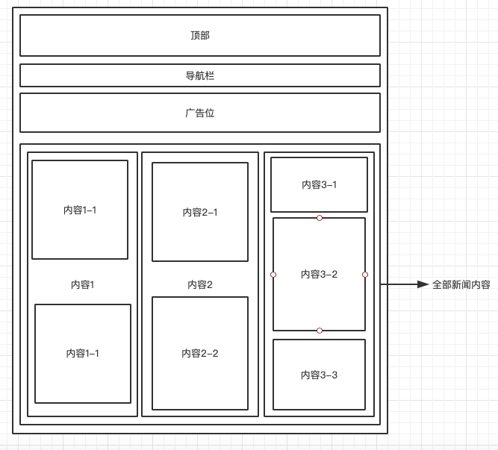

1. html代码

<div class="news">

<div class="top">

<div class="top-logo"><img src="../img/top-logo.png" alt=""></div>

<div class="top-search"><img src="../img//top-search.png" alt=""></div>

<div class="top-btn"><img src="../img//top-btn.png" alt=""></div>

</div>

<div>

<img src="../img/tab-contol.png" alt="">

</div>

<div>

<img src="../img/ad.png" alt="">

</div>

<div class="content">

<div>

<div><img src="../img/content1.png" alt=""></div>

<div><img src="../img/content1_2.png" alt=""></div>

</div>

<div>

<div><img src="../img/content2.png" alt=""></div>

<div><img src="../img/content4.png" alt=""></div>

</div>

<div>

<div><img src="../img/category.png" alt=""></div>

<div><img src="../img/content3.png" alt=""></div>

<div><img src="../img/content5.png" alt=""></div>

</div>

</div>

</div>

1. css代码

body{

margin: 0;

padding: 0;

box-sizing: border-box;

}

.news{

display: flex;

flex-direction: column;

justify-content: center;

align-items: center;

}

.top{

width: 98%;

height: 80px;

display: flex;

}

.top div{

display: flex;

justify-content: center;

align-items: center;

}

.top-logo,

.top-btn

{

width: 20%;

}

.top-search{

width: 60%;

}

.content{

display: flex;

}

1. 实验结果

